**Lesson15 Azure Plan Service Linux Lab**

**Notes:-**

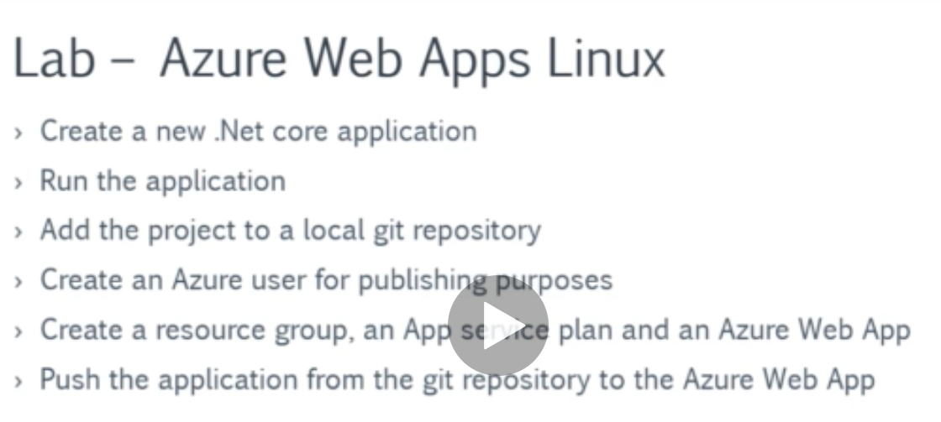

**1-on azure powershell we execute the following commands**

**$location="West Europe"**

**$resourcegrp="DefaultResourceGroup-WEU"**

**$webappname="demoApp"**

**we issue the command to create a new App Service Plan**

**New-AzAppServicePlan -Name $webappname -Location $location -ResourceGroupName $resourcegrp -Tier Standard -is-linux**

**// Next, we issue the command to create a new Web App with App Service Plan**

**New-AzWebApp -Name $webappname -Location $location -ResourceGroupName $resourcegrp -AppServicePlan $webappname**

**// Next, we issue the command to create a new Web App deployment slot**

**New-AzWebAppSlot -Name $webappname -ResourceGroupName $resourcegrp -Slot "staging"**